Faith and hope school album

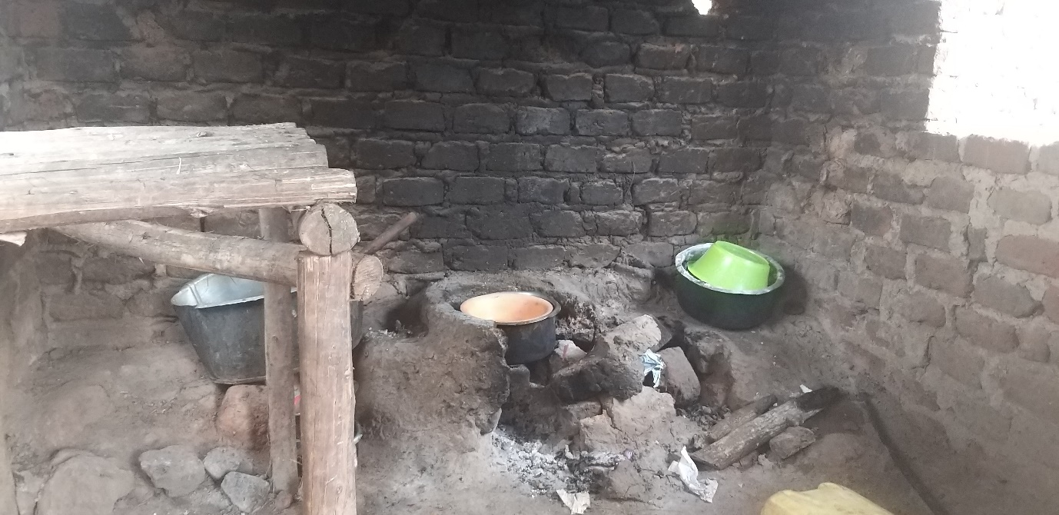
This is the current school kitchen

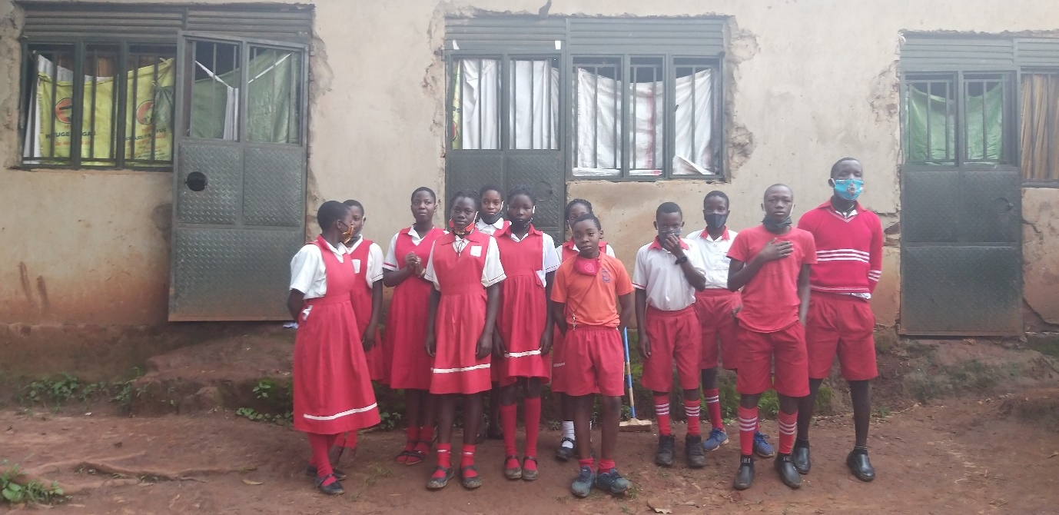

The current children’s at school behind are the school staff room used as dormitory

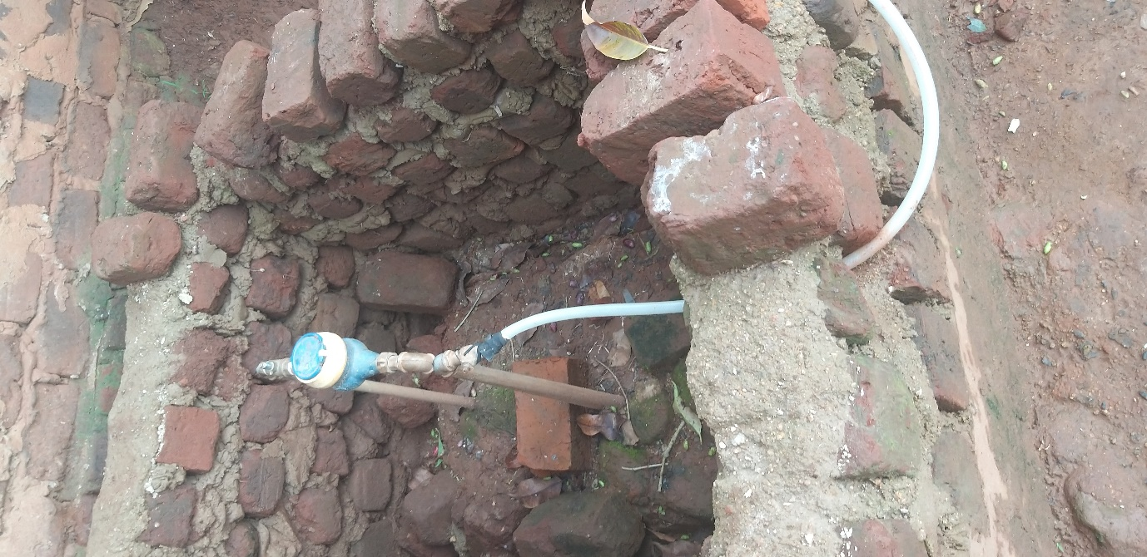

School is connected to the national water grid.

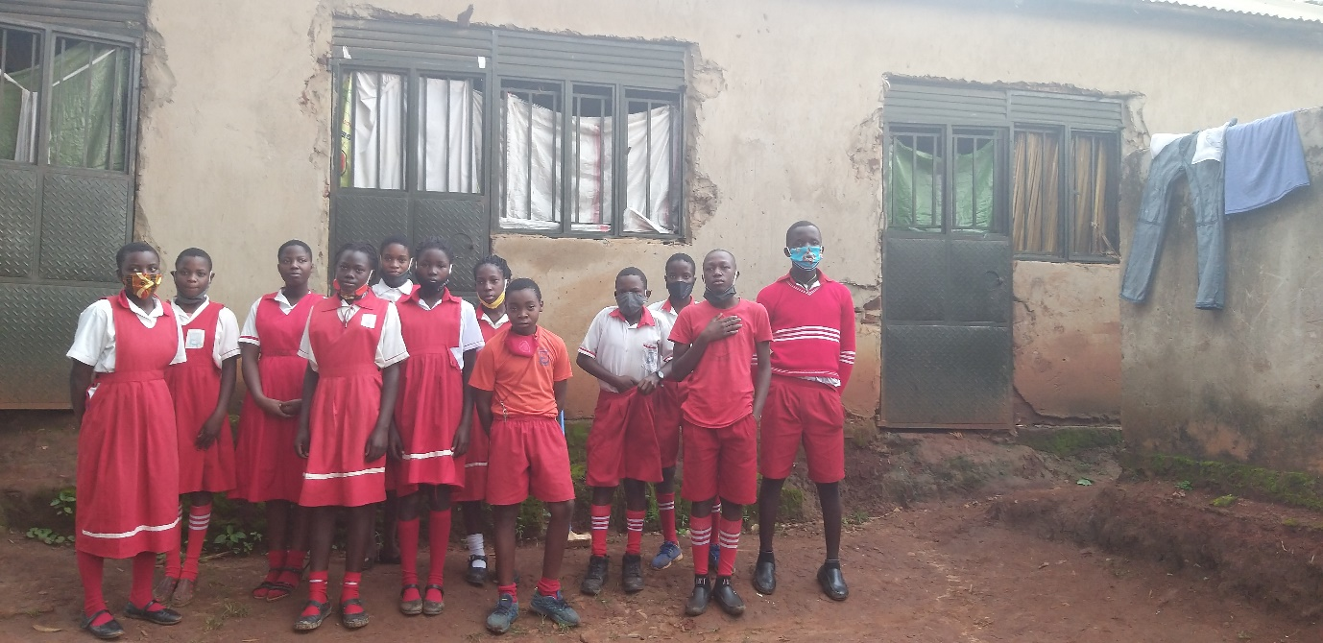

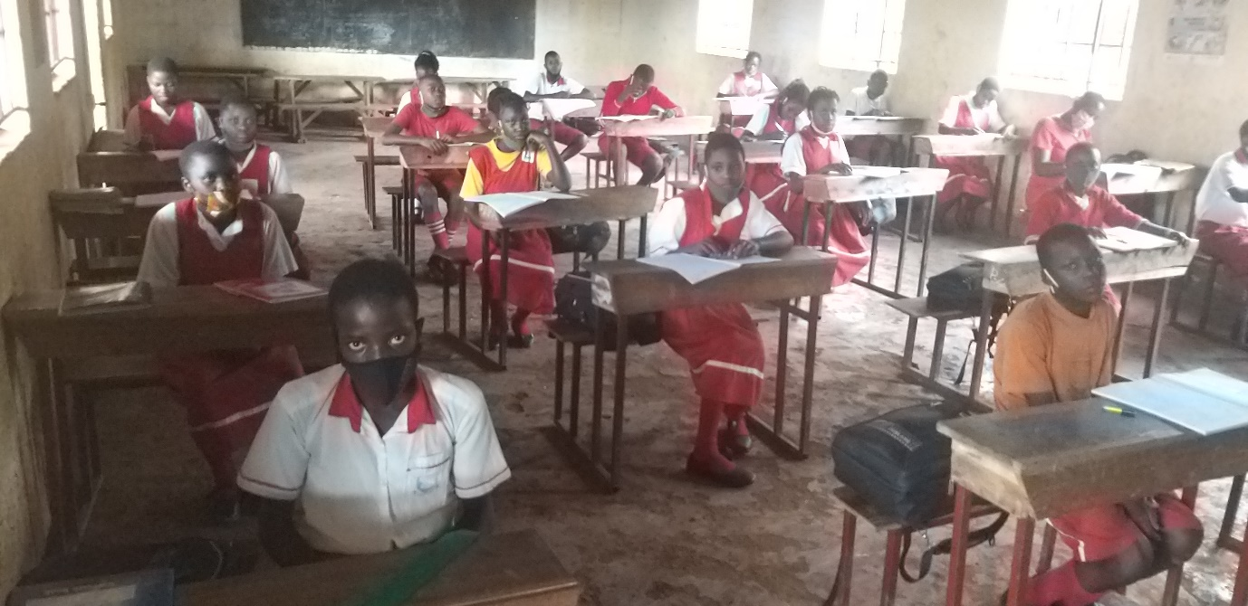
Classroom, candidate class of 22 pupils. (11-boys, and 11-girls) all staying at school as boarders in the staff houses accommodating as dormitory
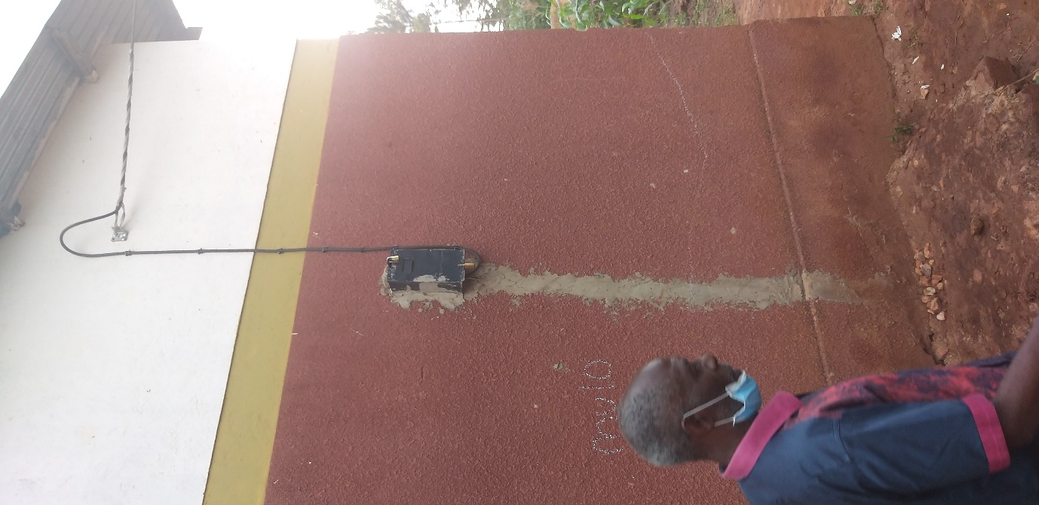
School connected to power supply, Infront is pr James
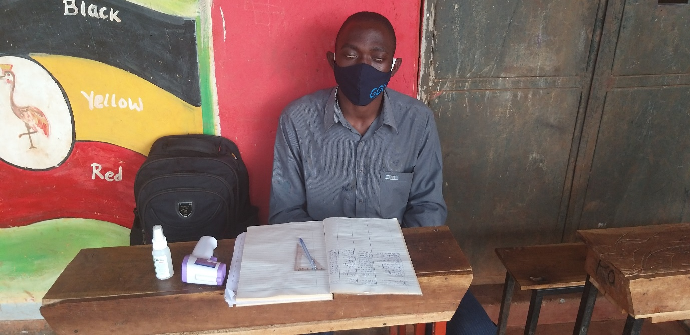

School nurse conducting COVID-19 , SCREEN INFRONT OF SCHOOL VERANDAR, SCHOOL HAS NO SICK ROOM
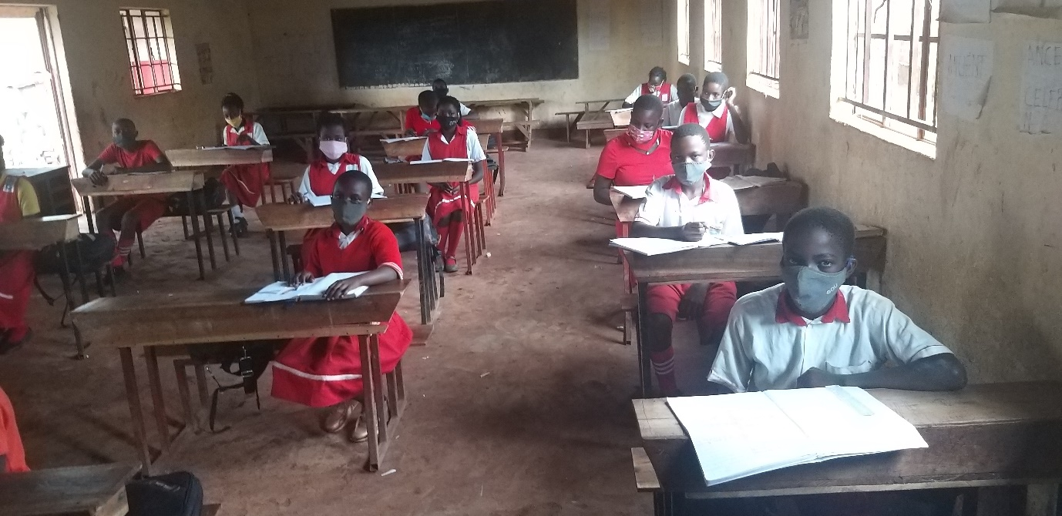

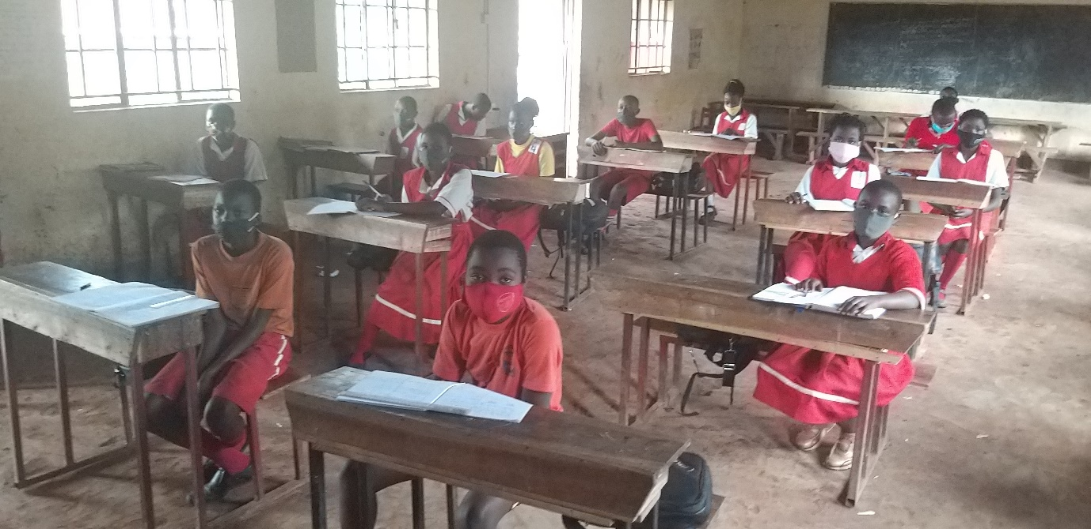

Pupils in classroom during the covid-19

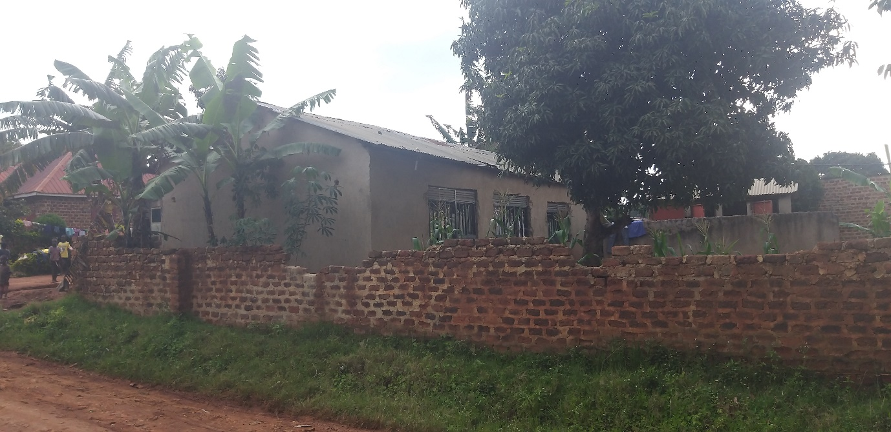

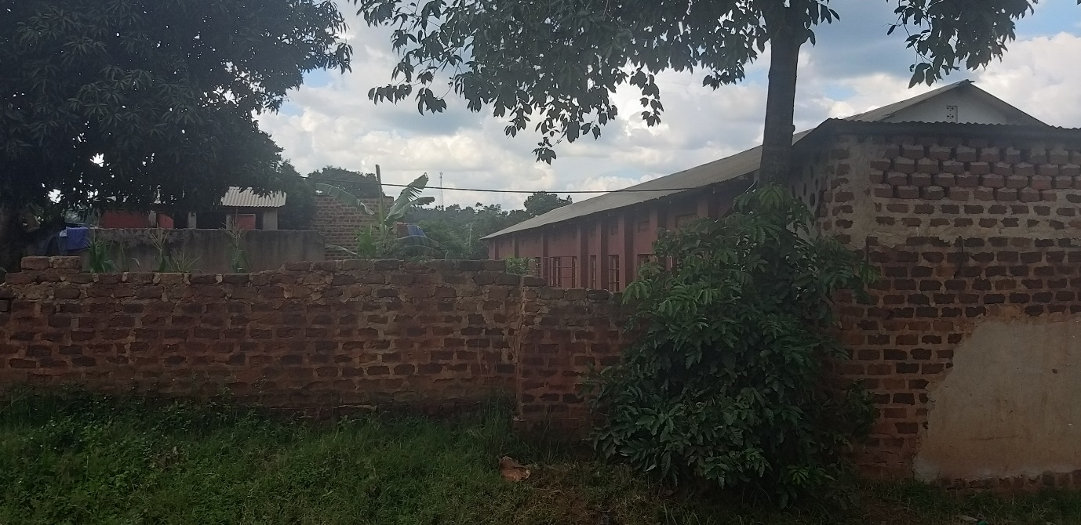

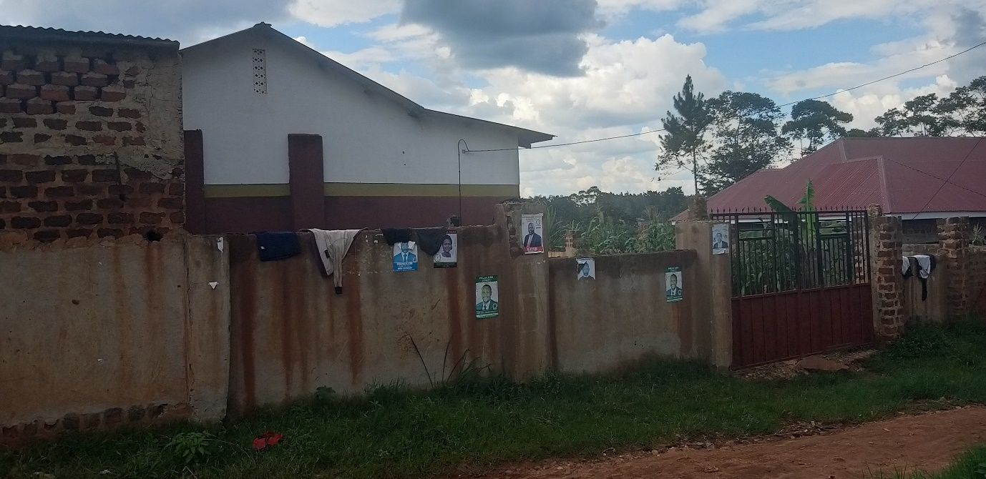
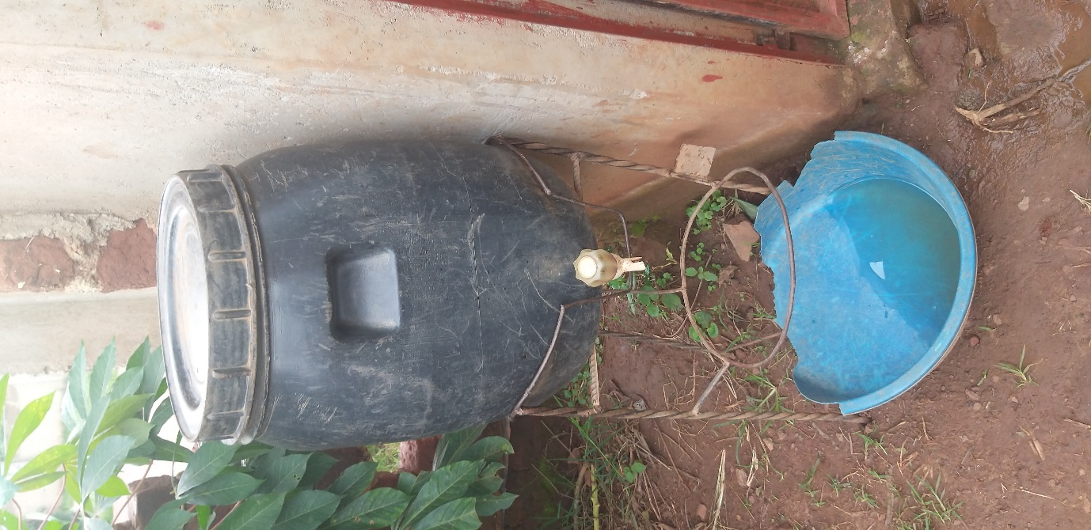

UP-DATE ON COVID-19 EFFECT ON FAITH AND HOPE SCHOOL.

The government had set out COVID-19 guide lines for all institution of learning from primary to university level to be observed and followed, of which any institution to be allowed to open or operate it must score 60% and above, if the score is less than 60% you are given approbation period of TWO-WEEKS to put things in place.
Then if the institution will be issued with a certificate of complaiance and allowed to operate legaly.
NOTE:
HOPE AND FAITH SCHOOL HAS 22-PUPILS in candidate class but the school is operating illegally, it only score 6% points thus the school is not supposed to operate.
The score were, water 3%, Perimeter wall(security)3%.
Power not rated.
The following were zero%
- Isolation room(school clinic )and school nurse stationed at school 24/7. Medically stocked
- School kitchen
- Staff house for teachers to stay at school 24/7
- Proper sanitation
- Foot operated washing hand machine
- Hand gun thermometer 3pcs
- 24/7 security guard
- Sanitizer should be available in all critical points
- Daily recording of pupils, staff, temperature
- Display covid-19 messages in all school premises
- COVID-19 -19 should be taken as lesson daily basis

Those are some to mention, as of current school need not less than 10million to score the 60% to secure the per mission to operate, some photos for your 9+observation.

Complied by
Sula sunday

To mention few

